# **How to prepare license plate?**

1. Create trucking company in the UI or use existing one.

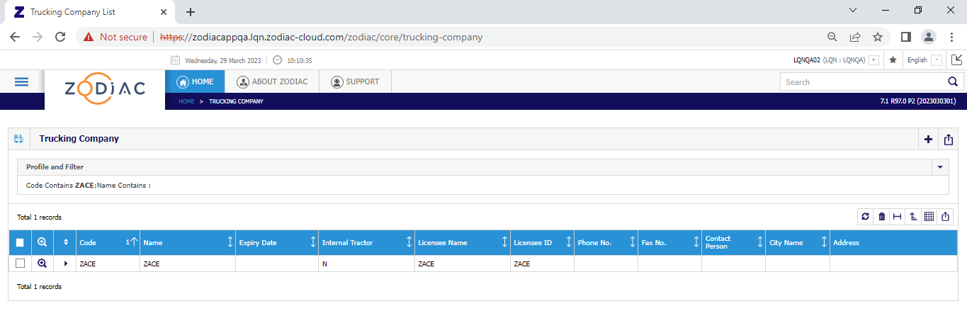

1. Open the template below



1. In the add tractor sheet, update the highlighted column (id and license plate). Just update the 2 rows then use fill handle in excel to fill the other rows. These columns must be unique so make sure to add non-existing data.

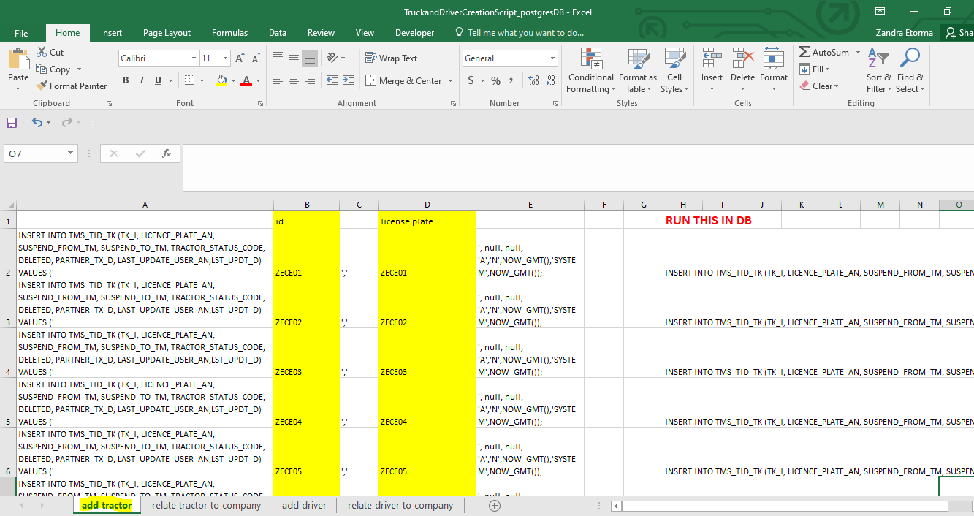

1. Copy all the constructed script and run on the tms db.

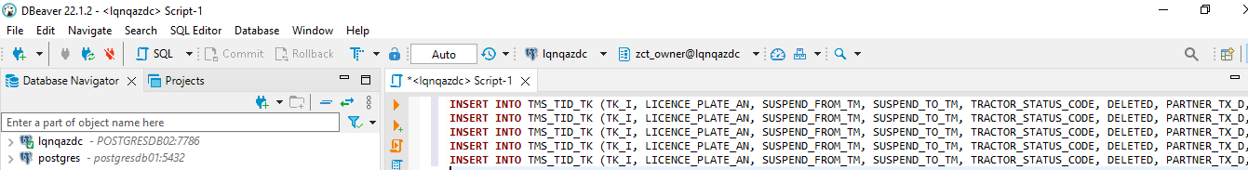

1. In the relate tractor to company sheet, update the highlighted column (trucking co. and license plate). Just copy the license plate from the add tractor sheet. For trucking company, just use one so that you can just copy to other rows.

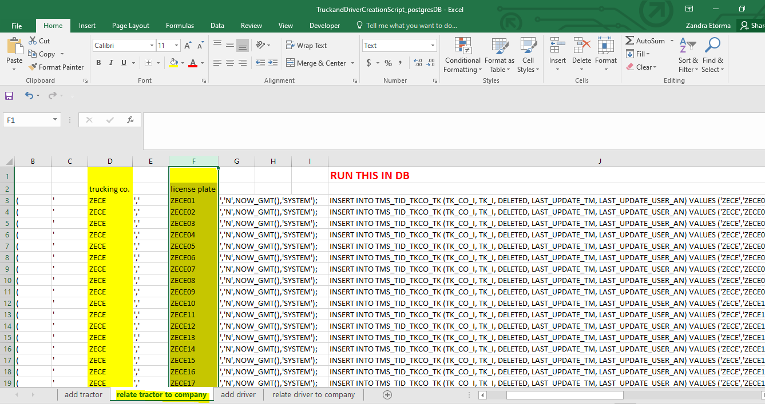

1. Copy all the constructed script and run on the tms db.

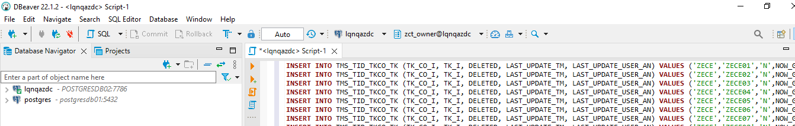

1. In the add driver sheet, update the highlighted column (trucking co., driver id and driver name). Just update the 2 rows then use fill handle in excel to fill the other rows. Driver ID must be unique so make sure to add non-existing data.

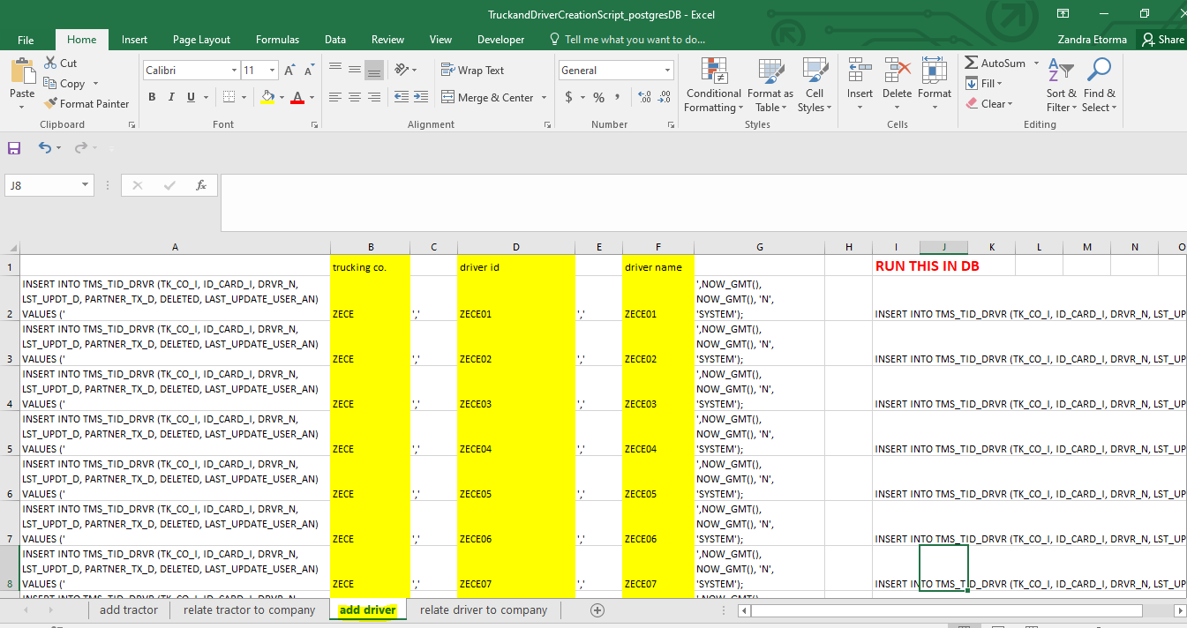

1. Copy all the constructed script and run on the tms db.

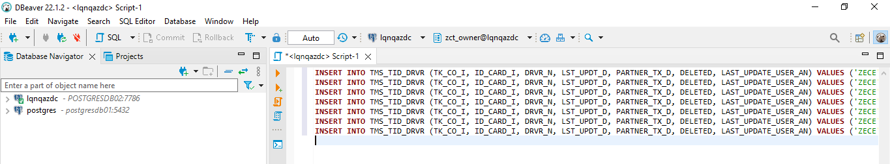

1. In the relate driver to company sheet, update the highlighted column (trucking co. and driver id). Just copy the trucking company and driver id from the add driver sheet.

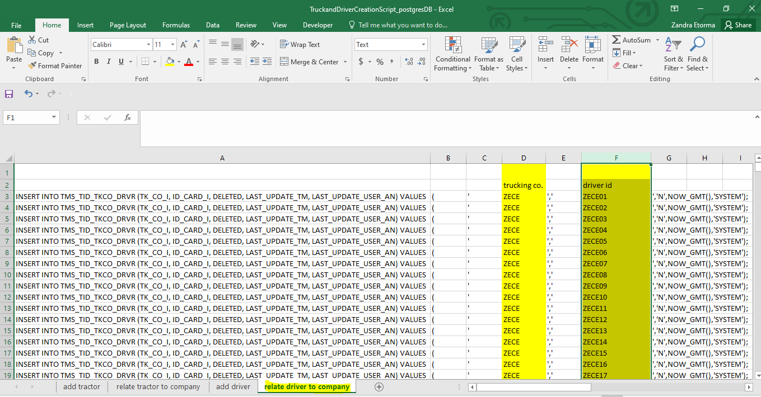

1. Copy all the constructed script and run on the tms db.

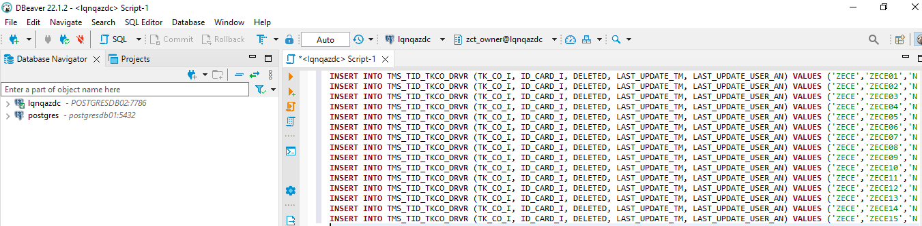

# **How to prepare import and export containers?**

## **Import**

1. Go to CA Web. Search for vessel visit with containers that are in yard and have yard location.

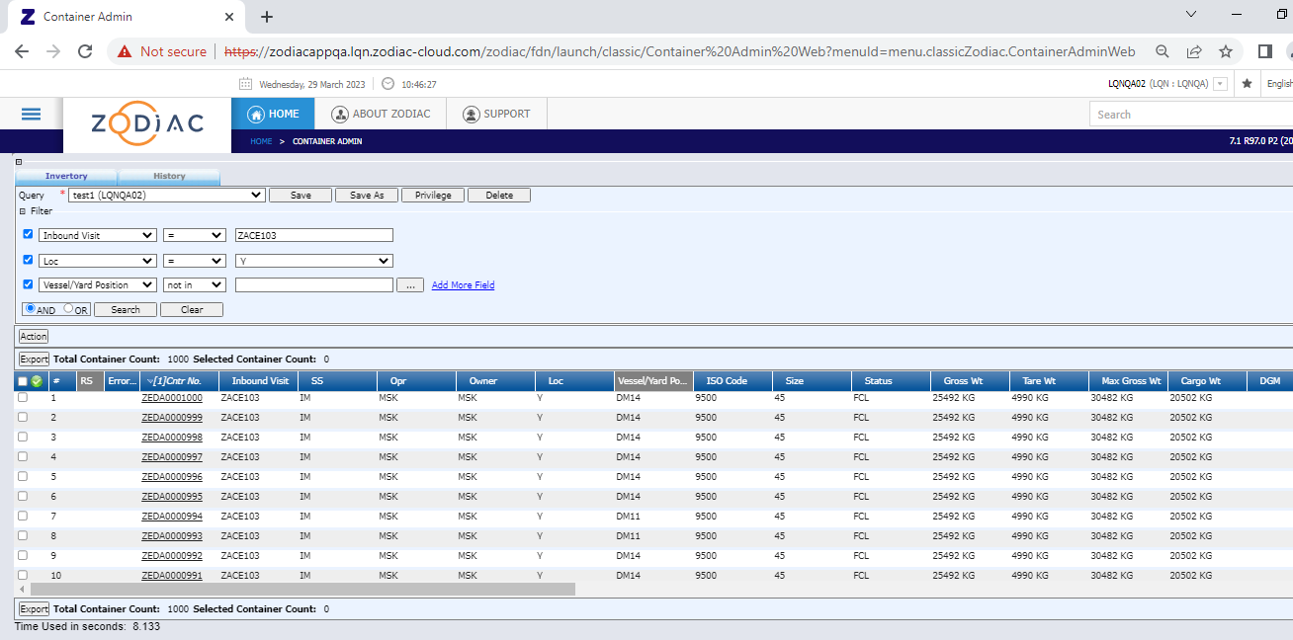

1. Remove all the Hold Codes if any.
2. Export the filtered list. Make sure to add the following columns before exporting. (operator, ISO Code)

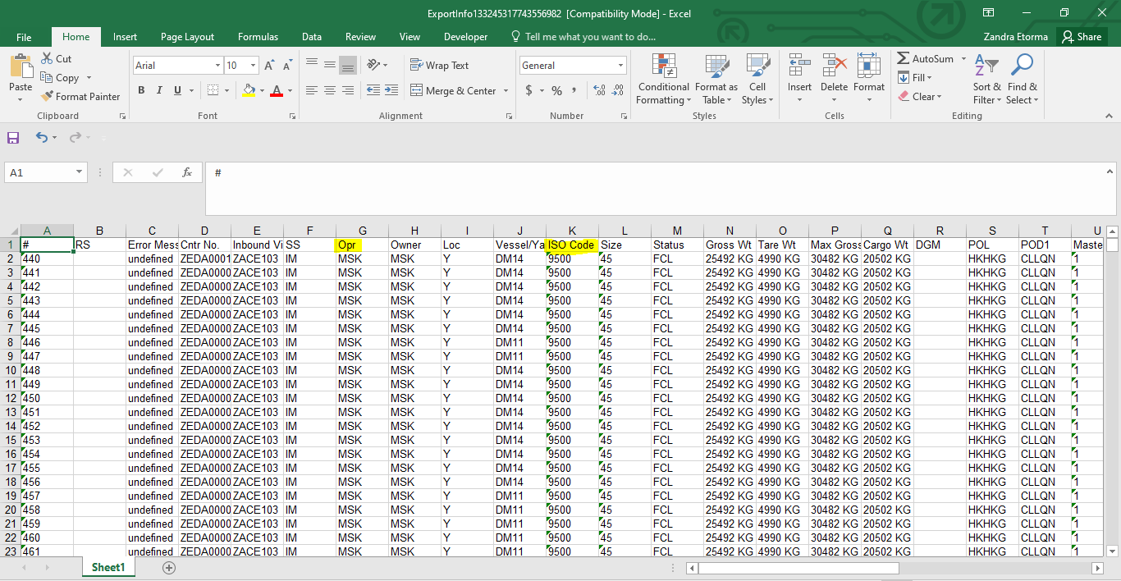

## **Export**

1. Prepare the template to preadvise containers. Use new containers number and just fill 2 rows and increment by 1. Put the same values in the other required fields on the 2 rows. Then use fill handle in excel to easily fill the other rows.



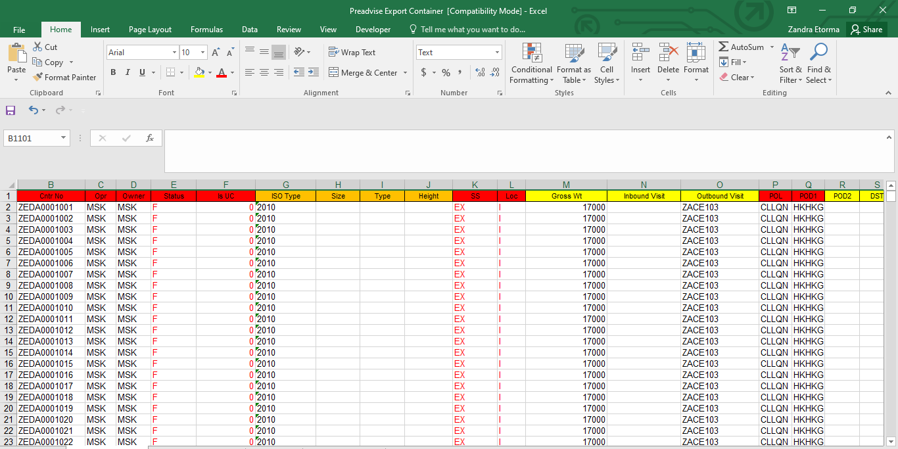

1. Create booking or use existing one. Make sure to have enough values in the quantity.

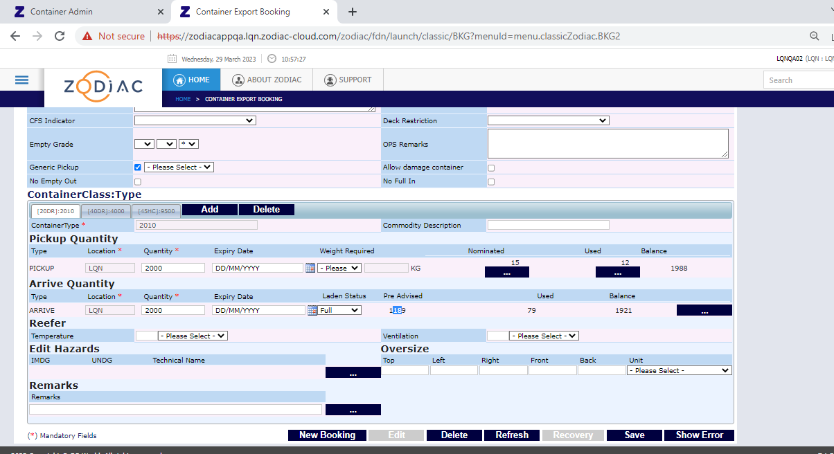

1. Preadvise the containers using the excel file.

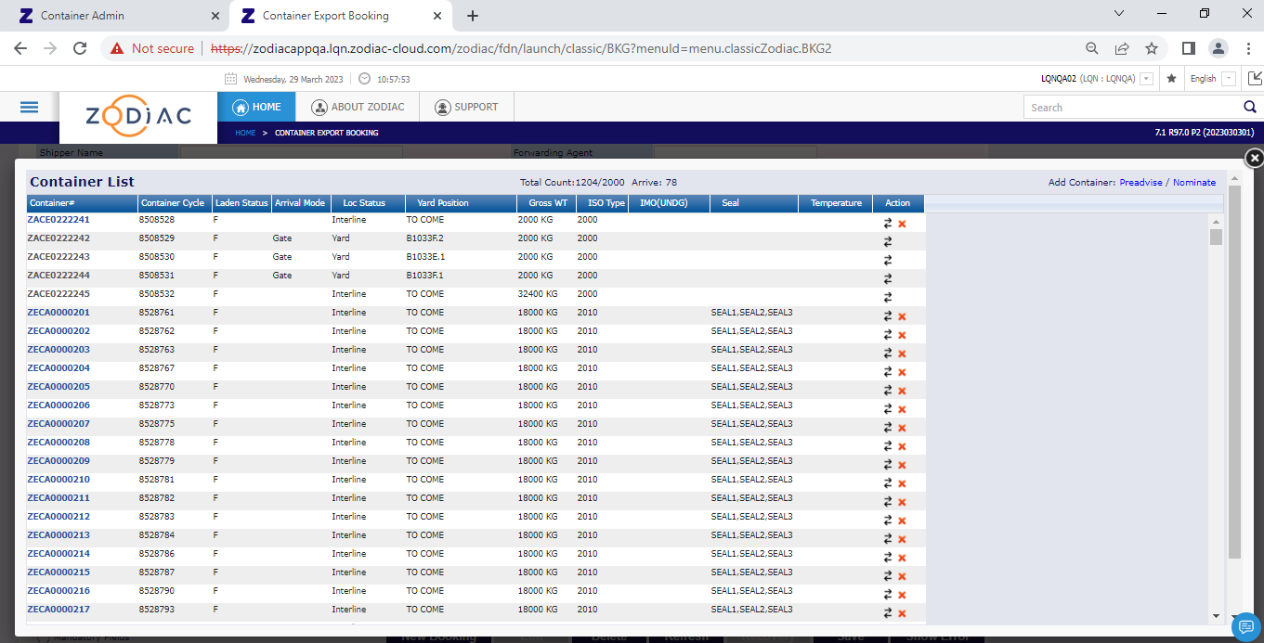

1. Go to CA and remove all the hold codes if any.

# **How to prepare bulk appointment via Postman?**

1. Open the template for bulk appointment.



1. Open the template used in creating tractors and drivers and copy the trucking company, license plate and driver Id and paste it on the highlighted column below.

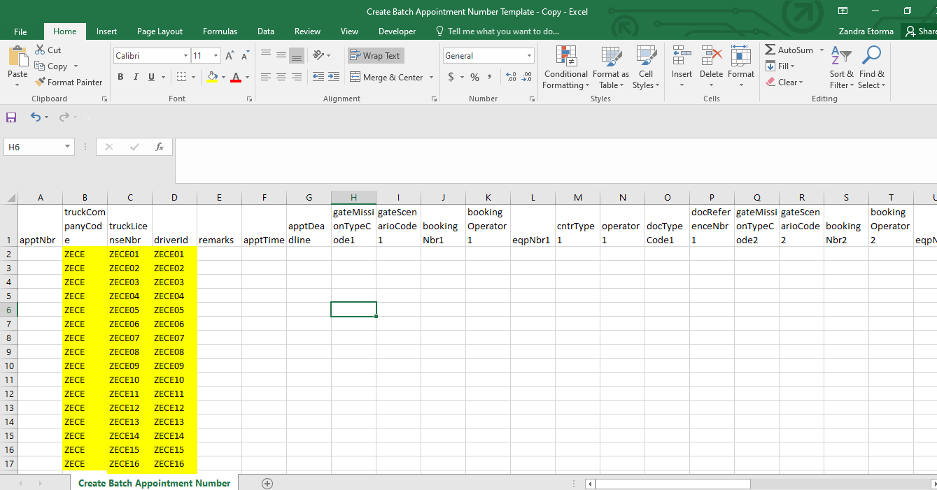

1. Open the exported excel from the CA for import containers and copy container number, ISO Code and operator. Paste it on the template for bulk appointment.

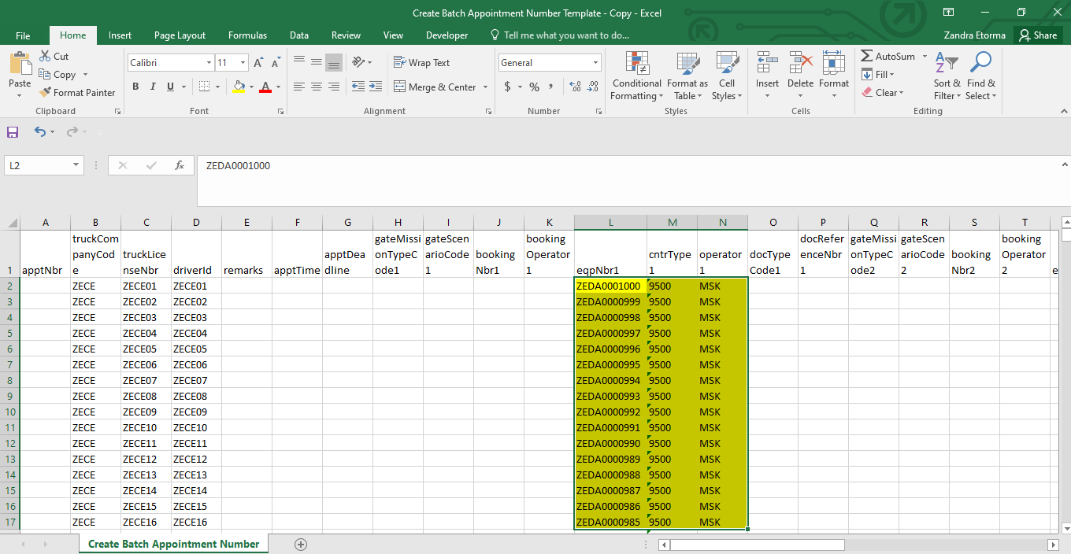

1. Add value in the gate mission type code and gate scenario code column. Then use fill handle in excel to copy the values to the other rows.

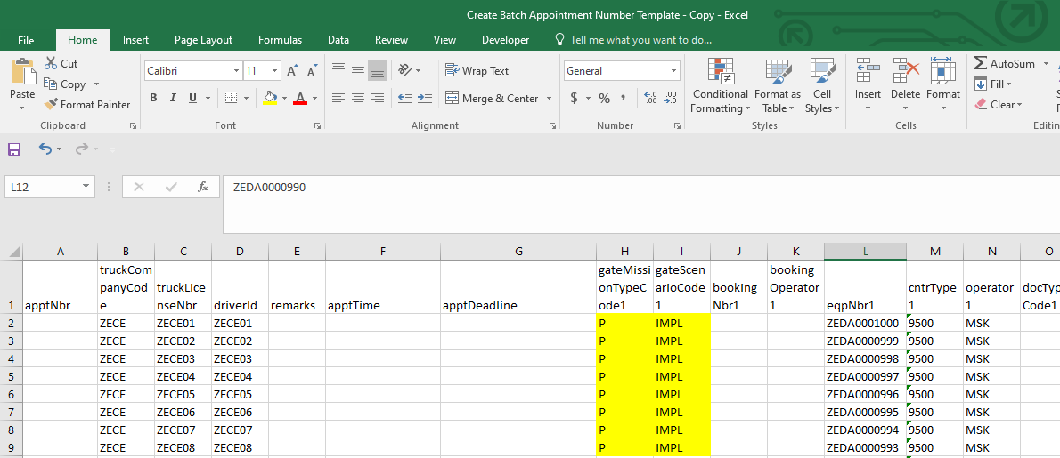

1. Open the preadvise template and copy container number, ISO Code and operator. Paste it on the template for bulk appointment same as the import containers.

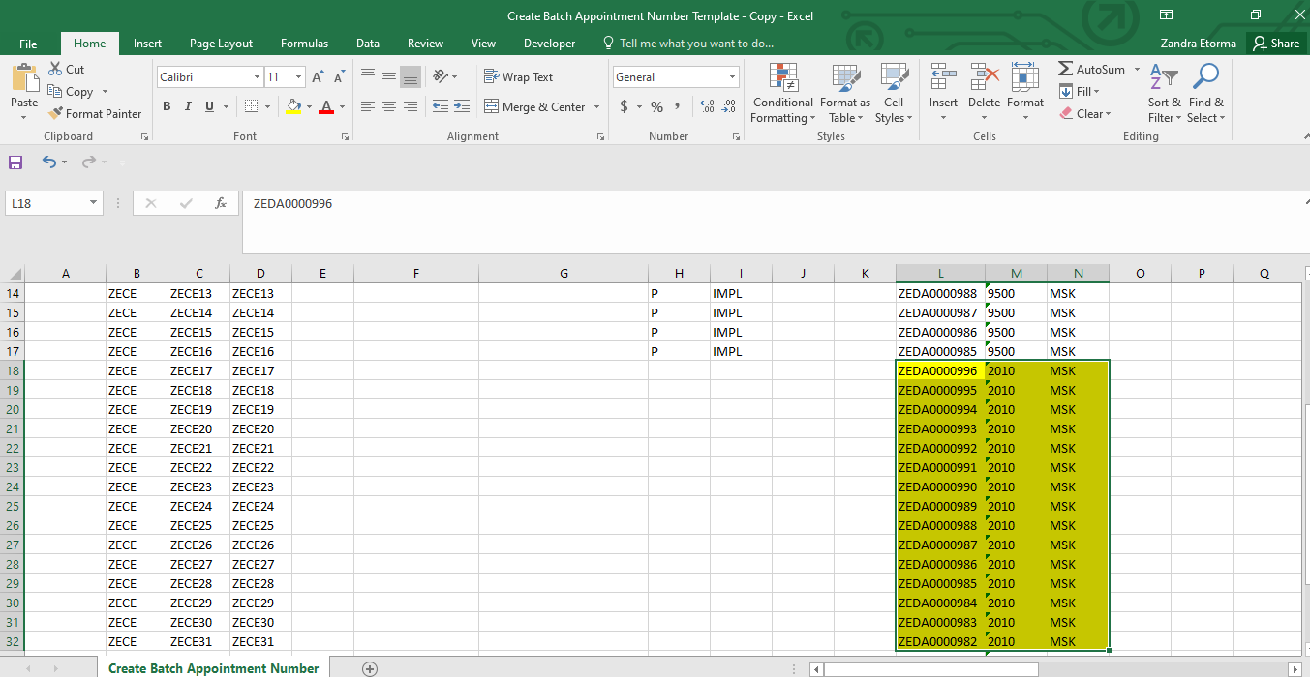

1. Add value in the gate mission type code, gate scenario code, booking number and booking operator column. Then use fill handle in excel to copy the values to the other rows.

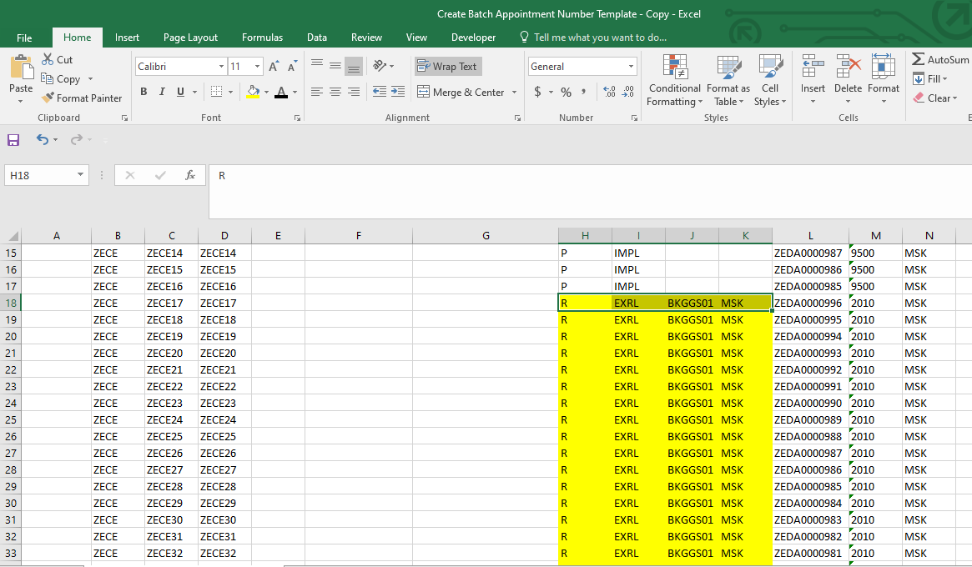

1. Add the start time and end time range for gate visit. Time is in UTC. Just fill the first row then use fill handle in excel if you want to have the same time for all visits.

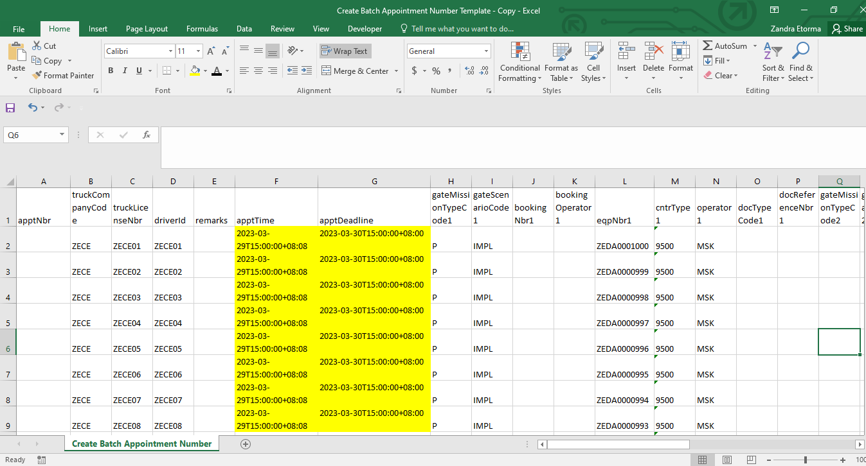

1. Add appointment number. Just fill out 2 row increment by 1. Then use fill handle in excel up to the last row to create appointment number incremented by 1. You can also add optional values for remarks, doc type code and doc reference number

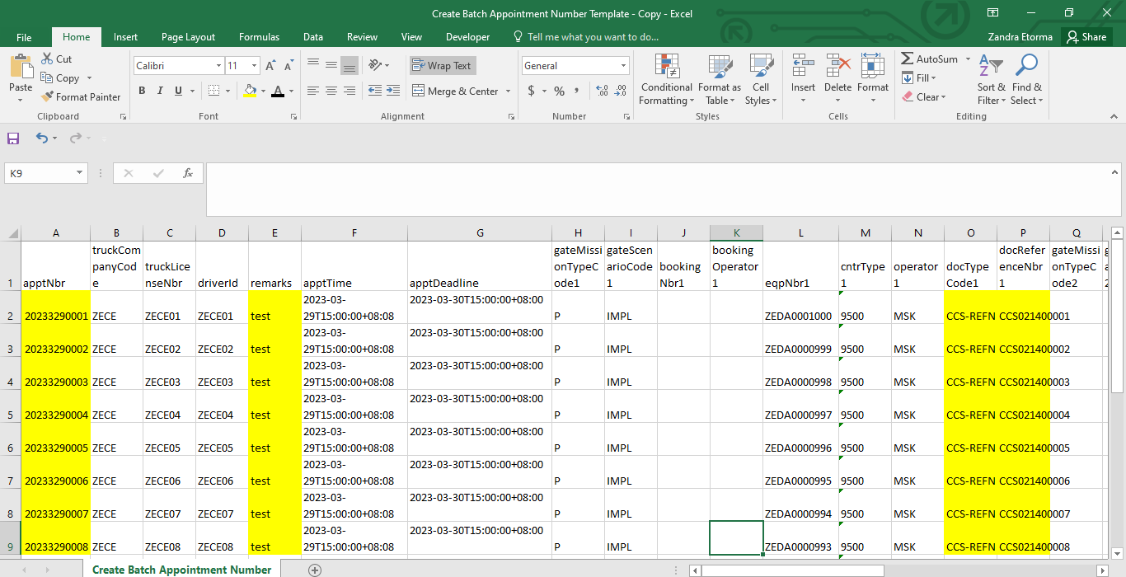

1. Save the file. Must be in CSV format.
2. Open postman. Must have imported the collection for bulk test data.



1. Generate authentication token.



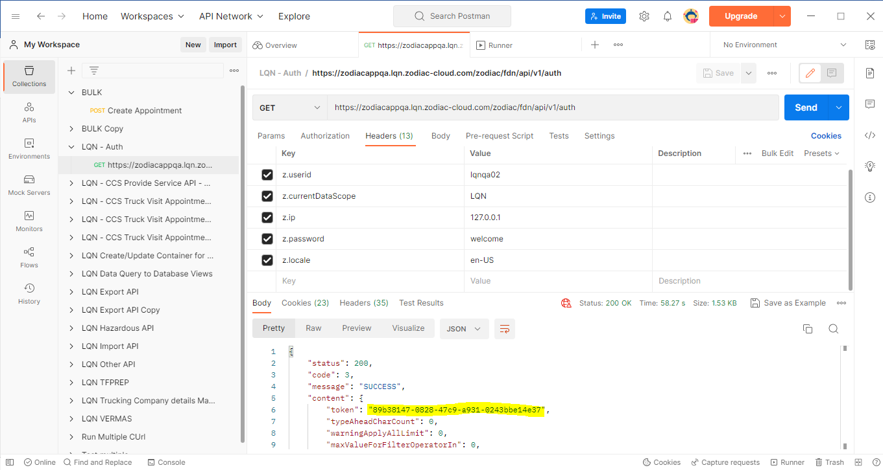

1. Copy the token and paste the token value in the bulk api and save.

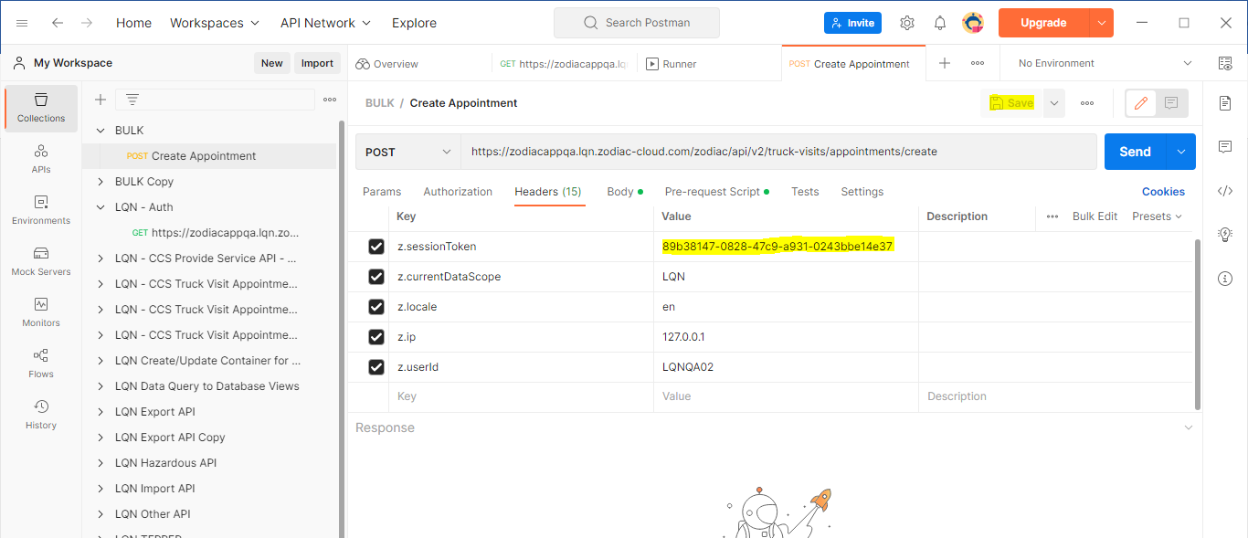

1. Go to the collection and select Run Collection from the burger icon.

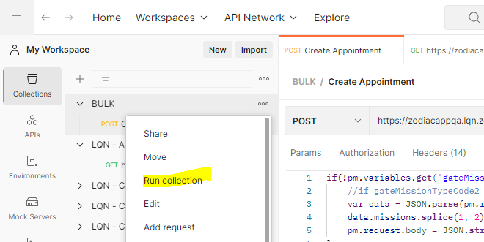

You will be redirected to this page

* Select the item to where the prepared request is located
* Select the prepared csv with data
* The iterations will be automatically populated on how many rows of test data you put in the csv

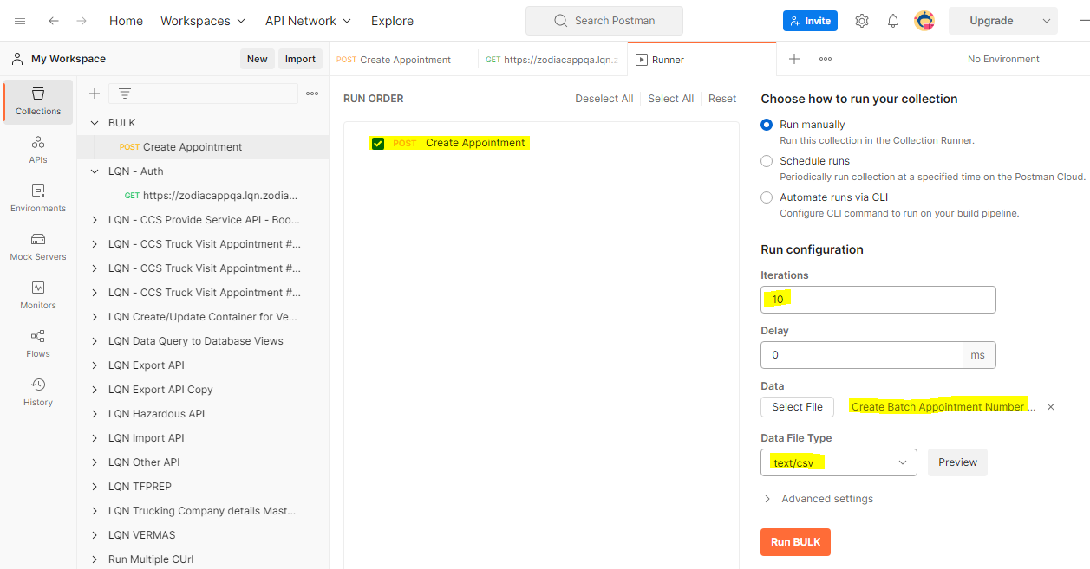

1. You can click on preview to show the list of test data

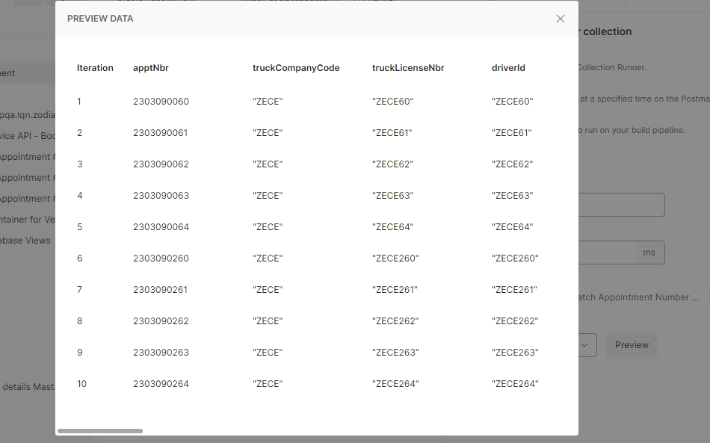

1. Click on Run Bulk button.

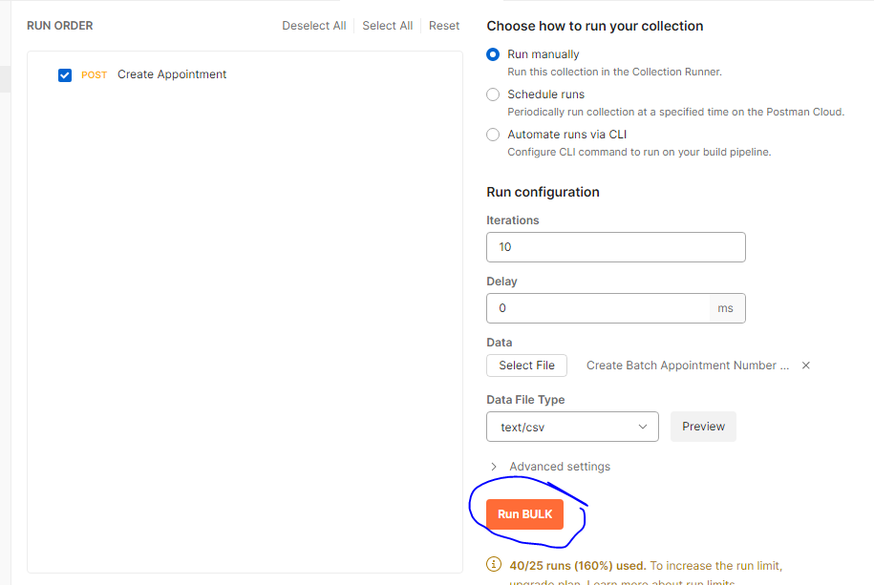

1. Click on Console button below to see the response. Must be success.

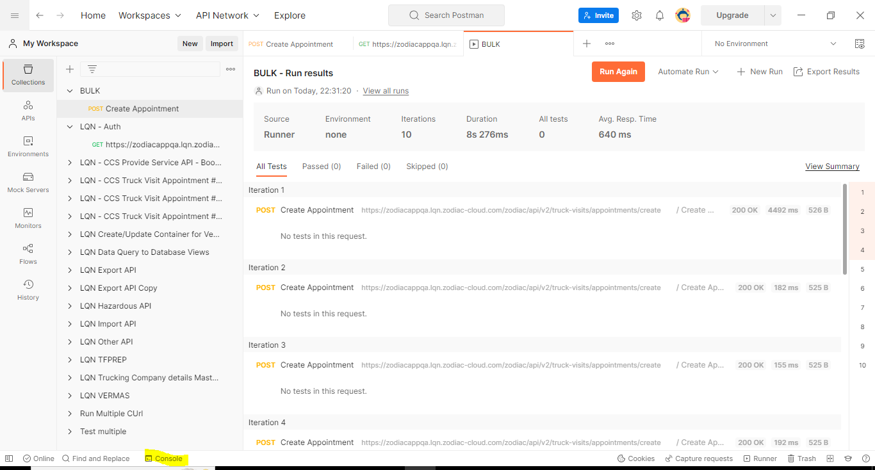

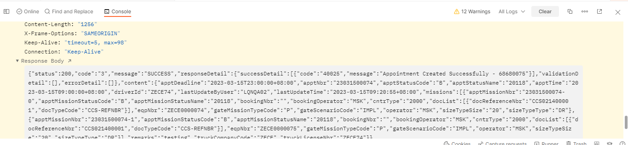

1. Once you’ve added successfully in the API, you can verify the appointment in the UI.

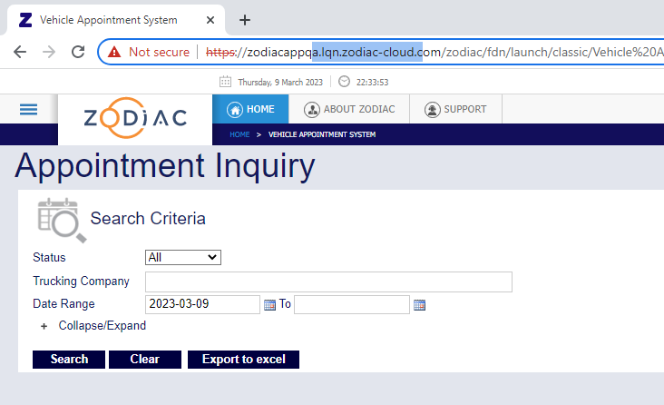

# **How to prepare excel for Katalon test data?**

1. Open the template to create the test data to be used in running gate simulation in katalon.



1. Select which site you are working on in the dropdown. It will automatically display those data that will be using when accessing the site like user, pass etc.

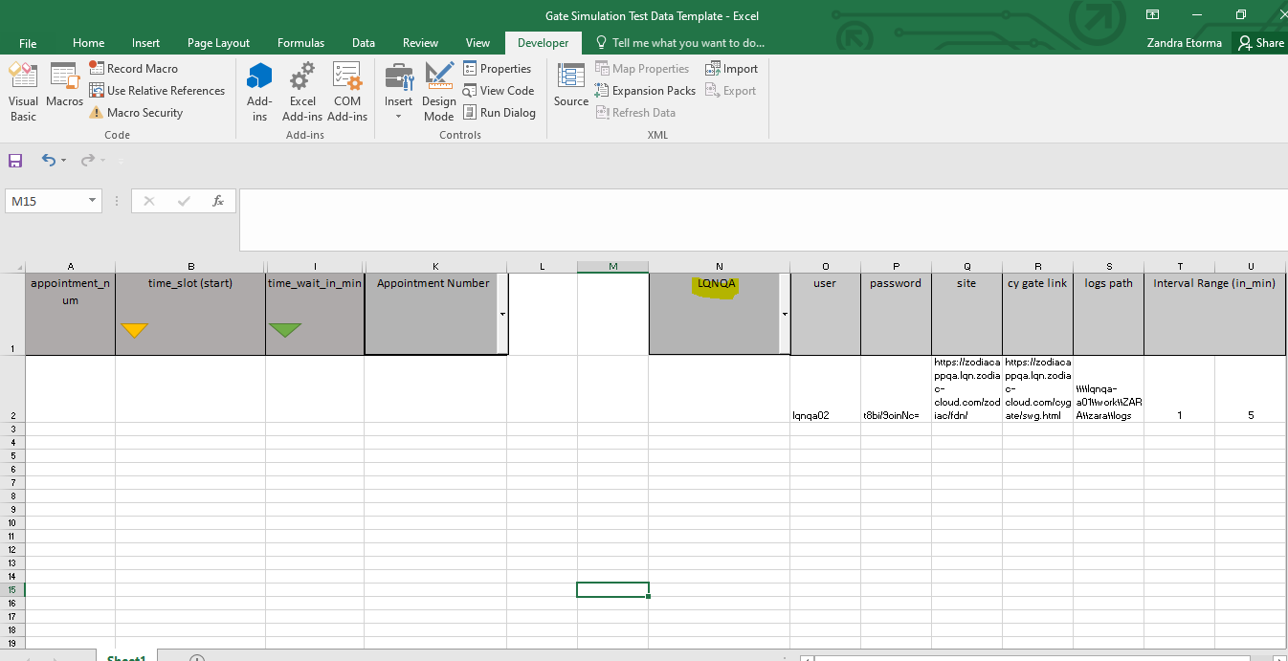

1. Choose appointment number in the dropdown and it will show you these required columns.

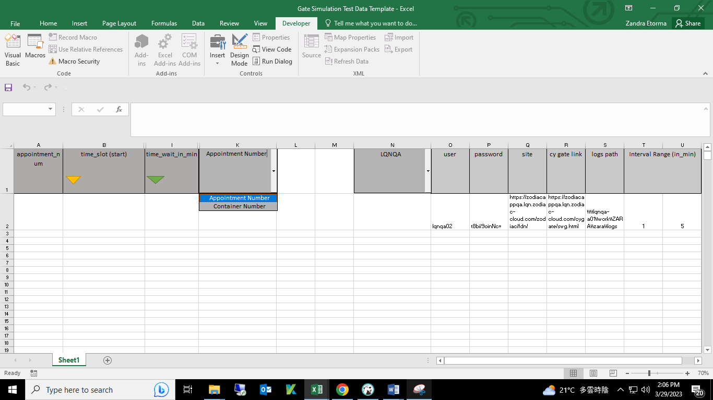

1. Add range for the interval per tractors.

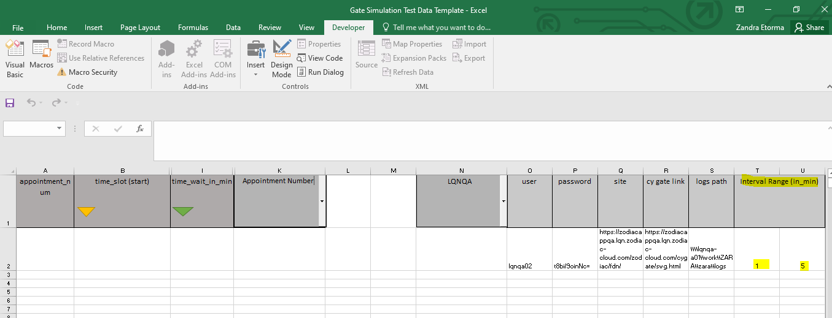

1. Copy the appointment number and start time (appTime column) from the bulk appointment template and paste it on the test data template.

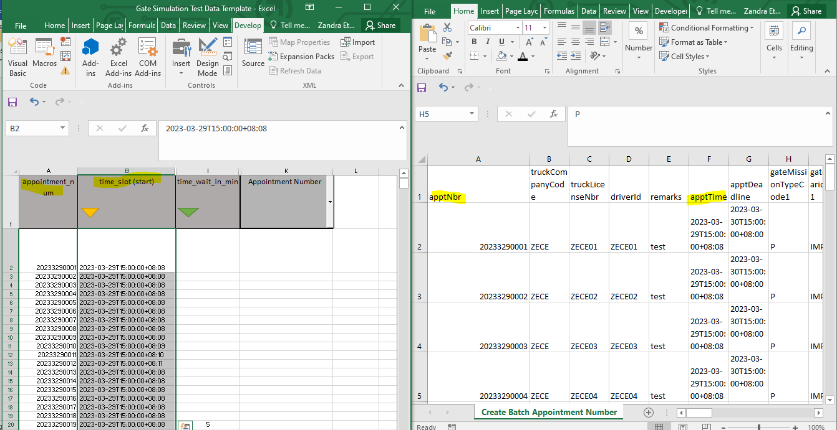

1. Click the button in time_slot to sort the appointment by time.
2. Click time_wait_in_min button to randomly assign interval to each truck based on the set range.

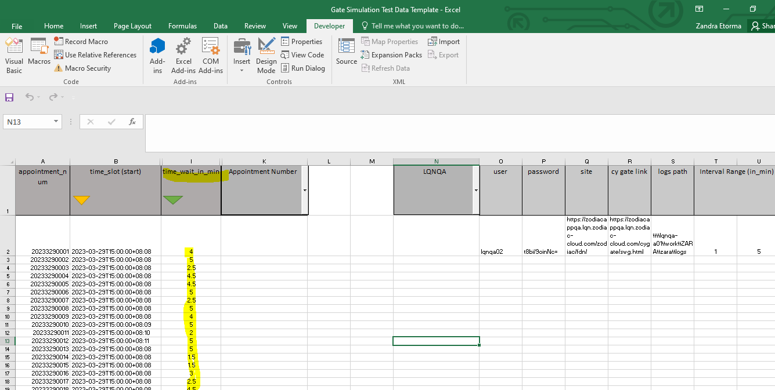

1. Save as xlsx file name should be **CY Gate Lane 1.**
2. Repeat steps to create another test data and file name should be **CY Gate Lane 2.**
3. Paste the created files to the test data folder inside the katalon.

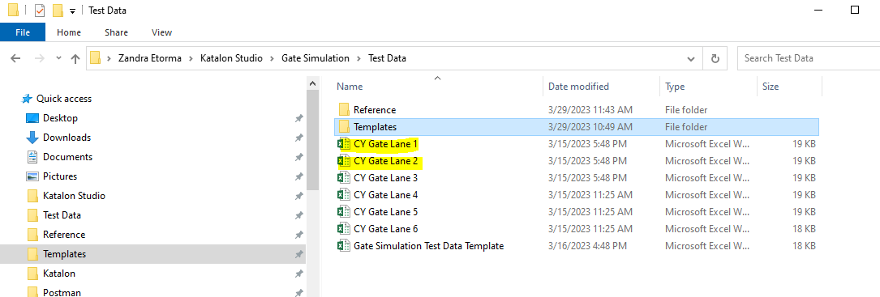

You can start running the automation.